Worksheet 2
Student Name: Anindita Dhar UID: 25MCA20259
Branch: MCA(General) Section/Group:25MCA-1-A
Semester: III Date of Performance:7/8/26
Subject Name: Internet Of Things Subject Code: 25CAH-708

Aim/Overview of the practical:
Interface a led, pushbutton (Pull Up) and LCD with Arduino Uno. Use two led and two pushbuttons. Use pushbutton as toggle switch.
  - Case 1: When press button 1 once then LED 1 will turn ON and print “Button1 ON” in Row 1 and “LED 1 ON” in Row 2.
  - Case 2: When we press button 1 again then LED 1 will turn OFF and print “Button1 OFF” in Row 1 and “LED 1 OFF” in Row 2.
  - Case 3: When we press button 2 once then LED 2 will turn ON and print “Button2 ON” in Row 1 and “LED 2 ON” in Row 2.
  - Case 4: When we release button 2 again then LED 2 will turn OFF and print “Button2 OFF” in Row 1 and “LED2 OFF” in Row 2.

Apparatus
Hardware Requirements: Arduino Uno R3 Board
LCD LED
Pushbutton

Software requirements: Microsoft Windows 10
TinkerCAD
- Circuit Diagram(TinkerCad):
Case 1:

Coding:
#include <LiquidCrystal.h> LiquidCrystal lcd(12, 11, 5, 4, 3, 2);

const int button1 = 7; const int button2 = 8; const int led1 = 9; const int led2 = 10; bool led1State = false;

int lastButton1 = HIGH; int lastButton2 = HIGH;
void setup()
{
pinMode(button1, INPUT_PULLUP); pinMode(button2, INPUT_PULLUP);
pinMode(led1, OUTPUT); pinMode(led2, OUTPUT);
lcd.begin(16, 2);
lcd.clear();

lcd.setCursor(0, 0); lcd.print("Ready");
digitalWrite(led1, LOW); digitalWrite(led2, LOW);
}
void loop()
{
int b1 = digitalRead(button1); int b2 = digitalRead(button2);
// BUTTON 1 PRESSED
if (lastButton1 == HIGH && b1 == LOW)
{
led1State = !led1State; digitalWrite(led1, led1State); lcd.clear();

if (led1State)
{
lcd.setCursor(0, 0); lcd.print("Button1 ON");
lcd.setCursor(0, 1);
lcd.print("LED 1 ON");
}
delay(200);
}
lastButton1 = b1;
}

Output:
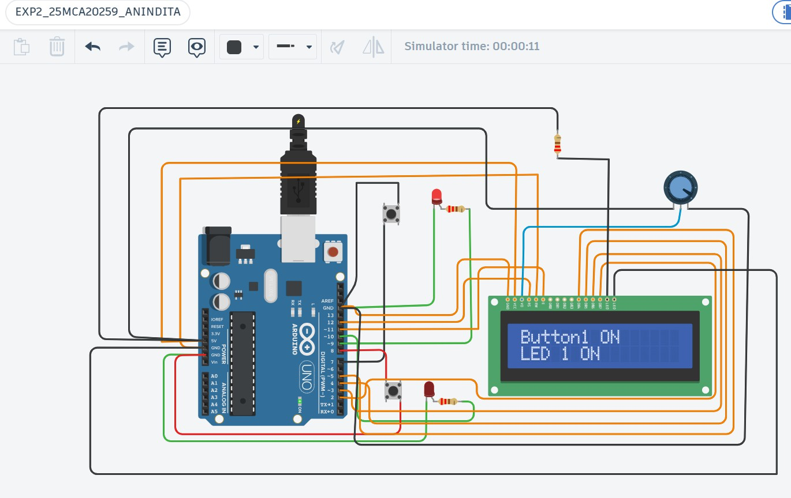
Case 2:

Coding:
#include <LiquidCrystal.h> LiquidCrystal lcd(12, 11, 5, 4, 3, 2);

const int button1 = 7; const int button2 = 8; const int led1 = 9; const int led2 = 10;

bool led1State = false;
int lastButton1 = HIGH; int lastButton2 = HIGH;

void setup()
{
pinMode(button1, INPUT_PULLUP); pinMode(button2, INPUT_PULLUP); pinMode(led1, OUTPUT); pinMode(led2, OUTPUT);
lcd.begin(16, 2);
lcd.clear(); lcd.setCursor(0, 0); lcd.print("Ready");

digitalWrite(led1, LOW); digitalWrite(led2, LOW);
}
void loop()
{
int b1 = digitalRead(button1); int b2 = digitalRead(button2);
// BUTTON 1 PRESSED AGAIN
if (lastButton1 == HIGH && b1 == LOW)
{
led1State = false; digitalWrite(led1, LOW); lcd.clear(); lcd.setCursor(0, 0); lcd.print("Button1 OFF"); lcd.setCursor(0, 1);
lcd.print("LED 1 OFF");

delay(200);
}
lastButton1 = b1;
}

Output:
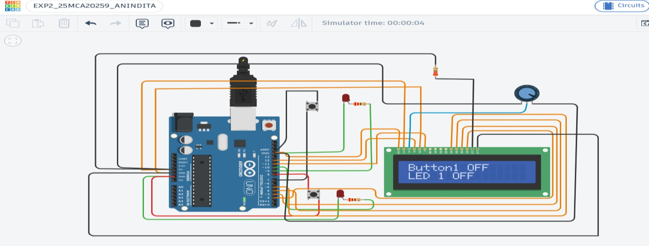

Case 3:
Coding:
#include <LiquidCrystal.h> LiquidCrystal lcd(12, 11, 5, 4, 3, 2);

const int button1 = 7; const int button2 = 8; const int led1 = 9; const int led2 = 10;

bool led1State = false;
int lastButton1 = HIGH; int lastButton2 = HIGH; void setup()
{
pinMode(button1, INPUT_PULLUP); pinMode (button2, INPUT_PULLUP); pinMode (led1, OUTPUT);
pinMode (led2, OUTPUT);
lcd.begin(16, 2);
lcd.clear(); lcd.setCursor(0, 0); lcd.print("Ready"); digitalWrite(led1, LOW); digitalWrite(led2, LOW);
}

void loop()
{
int b1 = digitalRead(button1); int b2 = digitalRead(button2);
// BUTTON 2 PRESSED
if (lastButton2 == HIGH && b2 == LOW)
{
digitalWrite(led2, HIGH); lcd.clear(); lcd.setCursor(0, 0); lcd.print("Button2 ON"); lcd.setCursor(0, 1);
lcd.print("LED 2 ON");
}
lastButton1 = b1; lastButton2 = b2; delay(50);

}

Output:
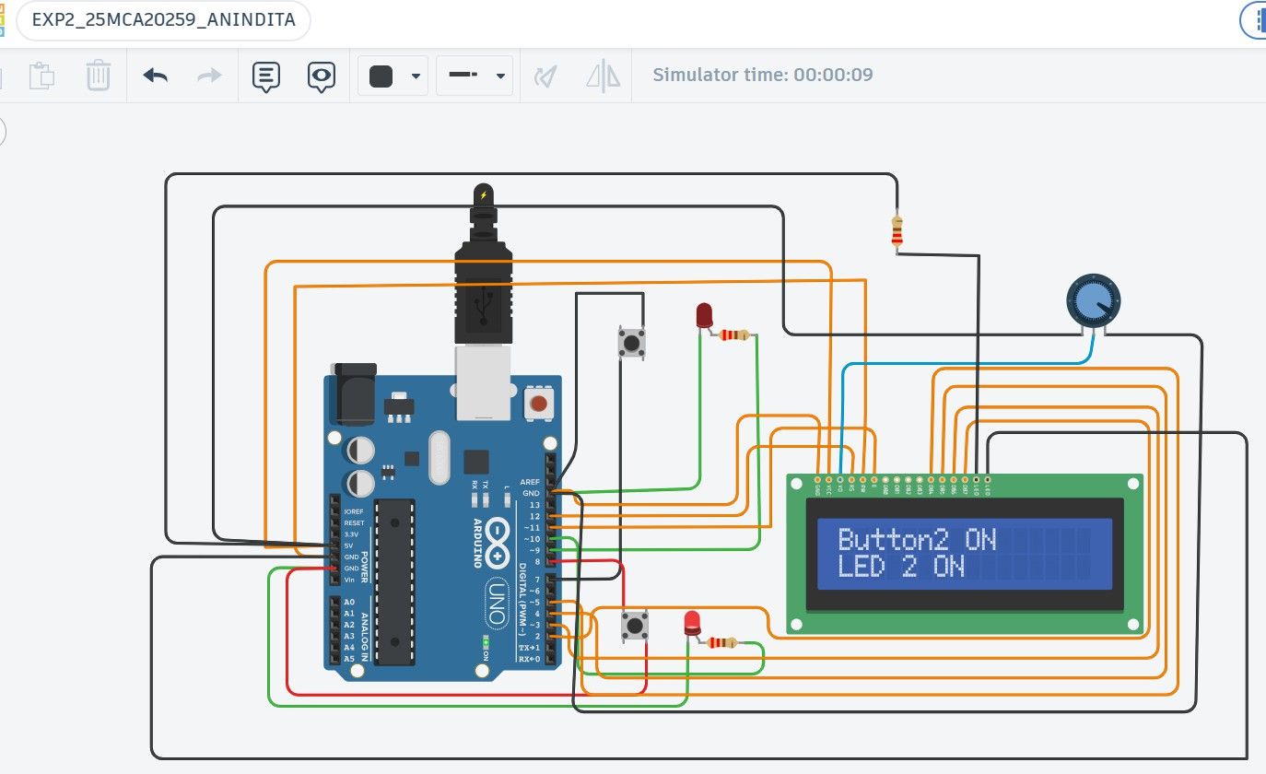

Case 4:
Coding:
#include <LiquidCrystal.h> LiquidCrystal lcd(12, 11, 5, 4, 3, 2); const int button1 = 7;
const int button2 = 8; const int led1 = 9; const int led2 = 10;
bool led1State = false;

int lastButton1 = HIGH; int lastButton2 = HIGH; void setup()
{
pinMode(button1, INPUT_PULLUP); pinMode(button2, INPUT_PULLUP); pinMode(led1, OUTPUT); pinMode(led2, OUTPUT);

lcd.begin(16, 2);
lcd.clear(); lcd.setCursor(0, 0); lcd.print("Ready");

digitalWrite(led1, LOW); digitalWrite(led2, LOW);
}
void loop()
{
int b1 = digitalRead(button1); int b2 = digitalRead(button2);
// BUTTON 2 RELEASED
if (lastButton2 == LOW && b2 == HIGH)
{
digitalWrite(led2, LOW); lcd.clear(); lcd.setCursor(0, 0); lcd.print("Button2 OFF"); lcd.setCursor(0, 1); lcd.print("LED2 OFF");
}2
lastButton1 = b1; lastButton2 = b2; delay(50);
}

Output:
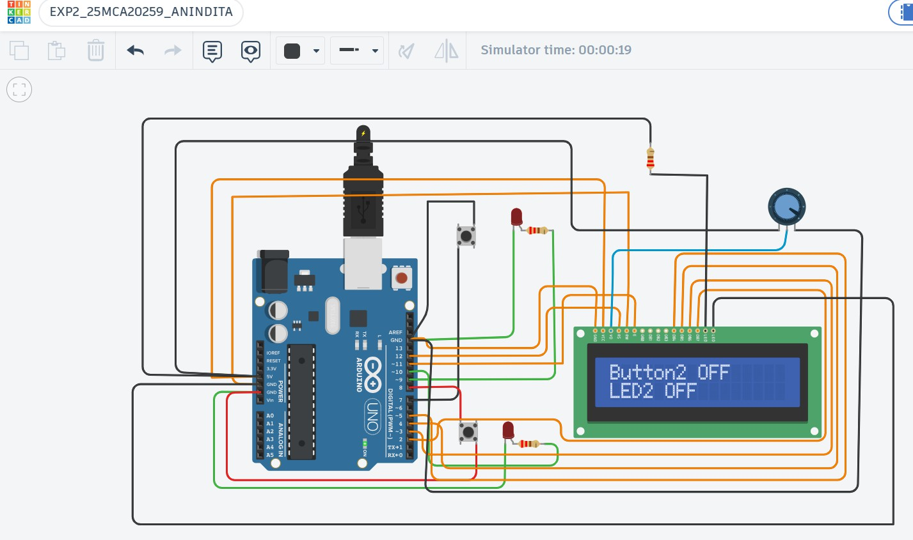

Learning outcomes (What I have learnt):
  - Using a 16*2 LCD in circuit.
  - Circuit formation using Arduino uno R3, push button, LED, LCD and potentiometer.
  - Integrating a potentiometer in a circuit.
  - Concepts of pull up and pull down in push button.
  - Components of 16*2 LCD,

